Welcome!
Date
Name
Spouse
Address
City
State Zip _________
Email

Please Contact By
❑ Card  Phone  Visit

Telephone Best Time to Call
Home ______________
Work ______________

Guest: First Time Second Time
Are you a church member: yes no
Church
City, State

Circle Appropriate Age/Grade Group(s)
Preschool: Ages: B-1 2-3 4-5
Children: Grades: K 1 2 3 4 5 6
Youth: Grades: 7 8 9 10 11 12
Adults: Ages:18-29 30s 40s 50s 60s+

How did you learn about our church?
Newspaper Friend Yellow Pages Mail
Other

I am a guest of:

New in the Community? Yes No
Names & ages of children at home

Weekly Service & Activity Schedule

November 16, 2014
9:45 a.m. Sunday School
11:00 a.m. Morning Worship Service
6:00 p.m. Evening Worship

Week of November 16
Wednesday, 7:00 p.m. Adult Prayer & Bible Study
There will be no Youth Bible Study Wednesday night
Thursday, 10:00 A.M. Adult Fellowship

Upcoming Events
November
……..…………....Collecting food for Thanksgiving Baskets
17-18………………………...BGCT Annual Meeting –Waco
27………………………………………………….Thanksgiving
December
1 – 6……………..Week of Prayer for Lottie Moon Missions
7…………………………………….…………….Kids In Action

Church committees for the New Year will need to meet as
soon as possible, choose a Committee Chair, and begin
planning for the upcoming year.

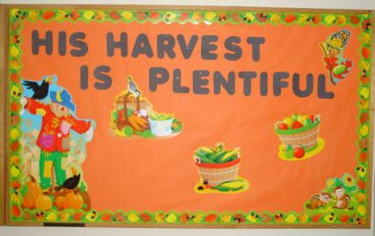

Knobbs Springs Baptist Church


Welcome Bro. James Roberts

November 16, 2014

Church Information:

KnobbsSpringsBC.com KnobbsSpringsBaptist@gmail.com
1662 CR 305, McDade, Texas 78650 512-273-2743
Patti Radford, Office Manager 512-968-7821

